Introduction

Introduction

* The AB Airline is online Flight Ticket Booking System.

Airline ticket booking system is that allows potential customers to book and pay for a flight ticket directly through the website.

* It provides two services like :

1.Oneway Booking

2.Roundway Booking

* The main purpose of this Project is that you can’t get Ticket at right time and you can’t visit the Safari Park. You can book an advance Online booking if you want to Book Tickets in advance.
* Sometimes,You can’t pass out Gir Forest CheckPost without permission so you also get advance Online Permitfor to pass Gir CeckPost.
* There is an Admin side which contains the admin login and through it admin can manage booking.

­­­­­­­­­­­­­­­

Student Profile

Student Profile

**StudentName :** Chauhan Bina K.

**EnrollmentNo :** 03052001099

**Stream :** BCA-5th

**CollageName :** Dr. Subhash College of Computer Science,Junagadh

**ContactNo :** 9408213117

**Address :** To:Visavadar Ta:Visavadar Dist:Junagadh

**EmailId :** [binakchauhan07@gmail.com](mailto:binakchauhan07@gmail.com)

**Guided By :** Asst. Prof. Bhavin Maheta

Student Profile

**StudentName :** Jivani Ankita C.

**EnrollmentNo :** 03052001100

**Stream :** BCA-5th

**CollageName :** Dr. Subhash College of Computer Science,Junagadh

**ContactNo :** 9406102500

**Address :** To:Visavadar Ta:Visavadar Dist:Junagadh

**EmailId :** [angelraghuvanshi51@gmail.com](mailto:angelraghuvanshi51@gmail.com)

**Guided By :** Asst. Prof. Bhavin Maheta

Project Profile

Project Profile

**Project Title :** Airline Ticket Booking

**Developed by :** Chauhan Bina K.

Jivani Ankita C.

**Semester :** BCA SEM-5

**Guidance by :** PHP, HTML5, CSS , JavaScript

**Platform :** PHP, MYSQLi

**Submitted by :** Dr. Subhash College of Computer Science, Junagadh

**Submitted To University :** BKNMU University-Junagadh

**Platform Used**

Platform Used

## What is PHP???

* PHP Stand for―Personal Home Page.
* PHP is server side scripting language, which can be embedded in HTML or used as a stand-alone.
* PHP is in official model of Apache HTTP Server.
* PHP is a widely-used, open source scripting language.
* PHP scripts are executed on the server.
* PHP costs nothing, it is free to download and use.
* PHP files can contain text, HTML, CSS, JavaScript, and PHP code. PHP code is executed on the server, and the result is returned to the browser as plain HTML.
* PHP files have extension "PHP". PHP can generate dynamic page content.
* PHP can create, open, read, write, delete, and close files on the server. PHP can send and receive cookies.
* PHP can add, delete, and modify data in your database.
* PHP can restrict users to access some pages on your website.
* PHP use by implementing:

<?php (code) ?>

* **Advantage of PHP:**
* **Cost :**

PHP Cost Is Nothing This Software Is Open Source Any One Can User At Free Of Cost.

### **Easy To Use :**

PHP Is Easy To Learn As Compare to Other Languages

### **Html Support :**

PHP Support HTML Then It Becomes Too Easy To Create A Designing.

### **Cross Platforms Capability :**

MYSQL Can Run In Both OS Like MICROSOFT WINDOWS AND UNIX.

## Speed :

**PHP** Gives More Speed To Run A Project With A Second.

## What is Database?

* + A database is a separate application that stores a collection of data.
  + Each database has one or more distinct APIs for creating, accessing, managing, searching and replicating the data it holds.
  + Other kinds of data stores can be used, such as files on the file system or large hash tables in memory but data fetching and writing would not be so fast and easy with those types of systems.
  + So nowadays, we use Relational Database Management Systems (RDBMS) to store and manage huge volume of data.
  + This is called relational database because all the data is stored into different tables and relations are established using primary keys or other keys known as foreign keys.

## RDBMS

A **Relational Database Management System (RDBMS)** is a software

that −

* Enables you to implement a database with tables, columns and indexes.
* Guarantees the Referential Integrity between rows of various tables.
* Updates the indexes automatically.
* Interprets an SQL query and combines information from various tables
  + - * **Referential Integrity** − Referential Integrity makes sure that a foreign key value always points to an existing row.

**Front & Back End Used**

Front End Used

## Front-end Technology :

1. **CSS,**
2. **HTML5,**
3. **PHP,**
4. **JAVASCRIPT,**
5. **BOOTSTRAP**

## Introduction of CSS :

* + **C**ascading **S**tyle **S**heets, fondly referred to as CSS, is a simple design language intended to simplify the process of making web pages presentable.
* CSS handles the look and feel part of a web page.
* Using CSS, you can control the colour of the text, the style of fonts, the spacing between paragraphs, how columns are sized and laid out, what background images or colours are used, layout designs, and variations in display for different devices and screen sizes as well as a variety of other effects.
* CSS is easy to learn and understand but it provides powerful control over the presentation of an HTML document.
  + Most commonly, CSS is combined with the markup languages HTML or XHTML.

## Advantages of CSS

* + - **CSS saves time** − you can write CSS once and then reuse same sheet in multiple HTML pages. You can define a style for each HTML element and apply it to as many Web pages as you want.
    - **Pages Load Faster** − If you are using CSS, you do not need to write HTML tag attributes every time. Just write one CSS rule of a tag and apply it to all the occurrences of that tag. So less code means faster download times.
    - **Easy Maintenance** − To make a global change, simply change the style, and all elements in all the web pages will be updated automatically.
    - **Superior styles to HTML** − CSS has a much wider array of attributes than HTML, so you can give a far better look to your HTML page in comparison to HTML attributes.

## Who Creates and Maintains CSS?

* CSS is created and maintained through a group of people within the W3C called the CSS Working Group.The CSS Working Group creates documents called specifications.
* When a specification has been discussed and officially ratified by the W3C members, it becomes a recommendation.
* These ratified specifications are called recommendations because the W3C has no control over the actual implementation of the language.
* Independent companies and organizations create that software.

**NOTE** − The World Wide Web Consortium, or W3C is a group that makes recommendations about how the Internet works and how it should evolve.

## What is HTML?

* + HTML is short for "Hypertext mark-up Language". That may sound scary, but it simply means it is a language for describing web-pages using ordinary text.
  + HTML is not a complex programming language. Hypertext is the method by which you move around on the web — by clicking on special text called hyperlinks which bring you to the next page.
  + The fact that it is hyper just means it is not linear.
  + HTML is a Language, as it has code-words and syntax like any other language.

## What is DHTML?

* + Dynamic Hypertext mark-up Language (**DHTML**) is a combination of Web development technologies used to create dynamically changing websites.
  + Web pages may include animation, dynamic menus and text effects.
  + The technologies used include a combination of HTML, JavaScript or VB Script, CSS and the document object model (DOM).

## What is New in HTML5?

* The DOCTYPE declaration for HTML5 is very simple: <!DOCTYPE html>
* The character encoding (charset) declaration is also very simple: < Meta charset="UTF-8">
* The most interesting new HTML5 elements are: New semantic elements like <header>, <footer>, <article>, and <section>.

* New attributes of form elements like number, date, time, calendar, and range.
* New graphic elements: <svg> and <canvas>.
* New multimedia elements: <audio> and <video>.

## Introduction of JavaScript :

* A scripting language is a lightweight programming language.
* JavaScript is programming code that can be inserted into HTML pages.
* JavaScript code can be executed by all modern web browsers.
* JavaScript is the scripting language of the Web.
* All modern HTML pages are using JavaScript.

**JavaScript** to program the behaviour of web pages.

## Introduction of BOOTSTRAP:

* Bootstrap is a free front-end framework for faster and easier **web development**.
* Bootstrap includes HTML and CSS based design templates for typography, forms, buttons, tables, navigation, modals, image carousels and many other, as well as optional **JavaScript plugins**.
* Bootstrap also gives you the ability to easily create **responsive designs**.

**Responsive web** design is about creating web sites which automatically adjust themselves to look good on all devices, from small phones to large desktops.

## Advantages of Bootstrap:

➔**Easy** **to** **use:**

* + Anybody with just basic knowledge of HTML and CSS can start using Bootstrap.

## ➔Responsive features:

* + Bootstrap's responsive CSS adjusts to phones, tablets, and desktops.

## ➔Mobile approach:

* + In Bootstrap 3, mobile-first styles are part of the core framework.

## Browser Compatibility:

* + Bootstrap is compatible with all modern browsers (Chrome, Firefox, Internet Explorer, Safari, and Opera).

Back End Used

**Back** **End** **Used**

* MySQLi

### **What is MYSQLi?**

* MySQLi is a Relational SQL database management system.
* ‘I’ Stand for IMPROVED.
* MySQLi is used inside the PHP programming language to give an interface with MySQL databases.

This tutorial will give you quick start with MySQLi and make you comfortable with MySQLi programming.

### **MySQLi Database**

* MySQLi is a fast, easy-to-use RDBMS being used for many small and big businesses. MySQLi Extension is developed, marketed, and supported by MySQL. MySQL is becoming so popular because of many good reasons.
* MySQLi is released under an open-source license. So you have nothing to pay to use it.
* MySQLi is a very powerful program in its own right. It handles a large subset of the functionality of the most expensive and powerful database packages.

* MySQLi uses a standard form of the well-known SQL data language.
* MySQLi works on many operating systems and with many languages including PHP, PERL, C, C++, JAVA, etc.
* MySQLi works very quickly and works well even with large data sets.
* MySQLi is very friendly to PHP, the most appreciated language for web development.
* MySQLi supports large databases, up to 50 million rows or more in a table.
* MySQL was a free-software database engine originally developed and first released in 1995.
* MySQL is named after My, the daughter Michael
* Wideness, of one of the product’s originators. It was originally produced under the GNU General Public License, in which source code is made freely available.
* MySQL is very popular for Web-hosting applications because of its plethora of Web-optimized features like HTML data types, and because it's available for free.

It is part of the Linux, Apache, MySQL, PHP (LAMP) architecture, a combination of platforms that is frequently used to deliver and support advanced Web applications.

**Project Analysis**

* **Implementation Methodology**
* All projects follow a life cycle model (SDLC). The most widely used SDLC model in our project is:

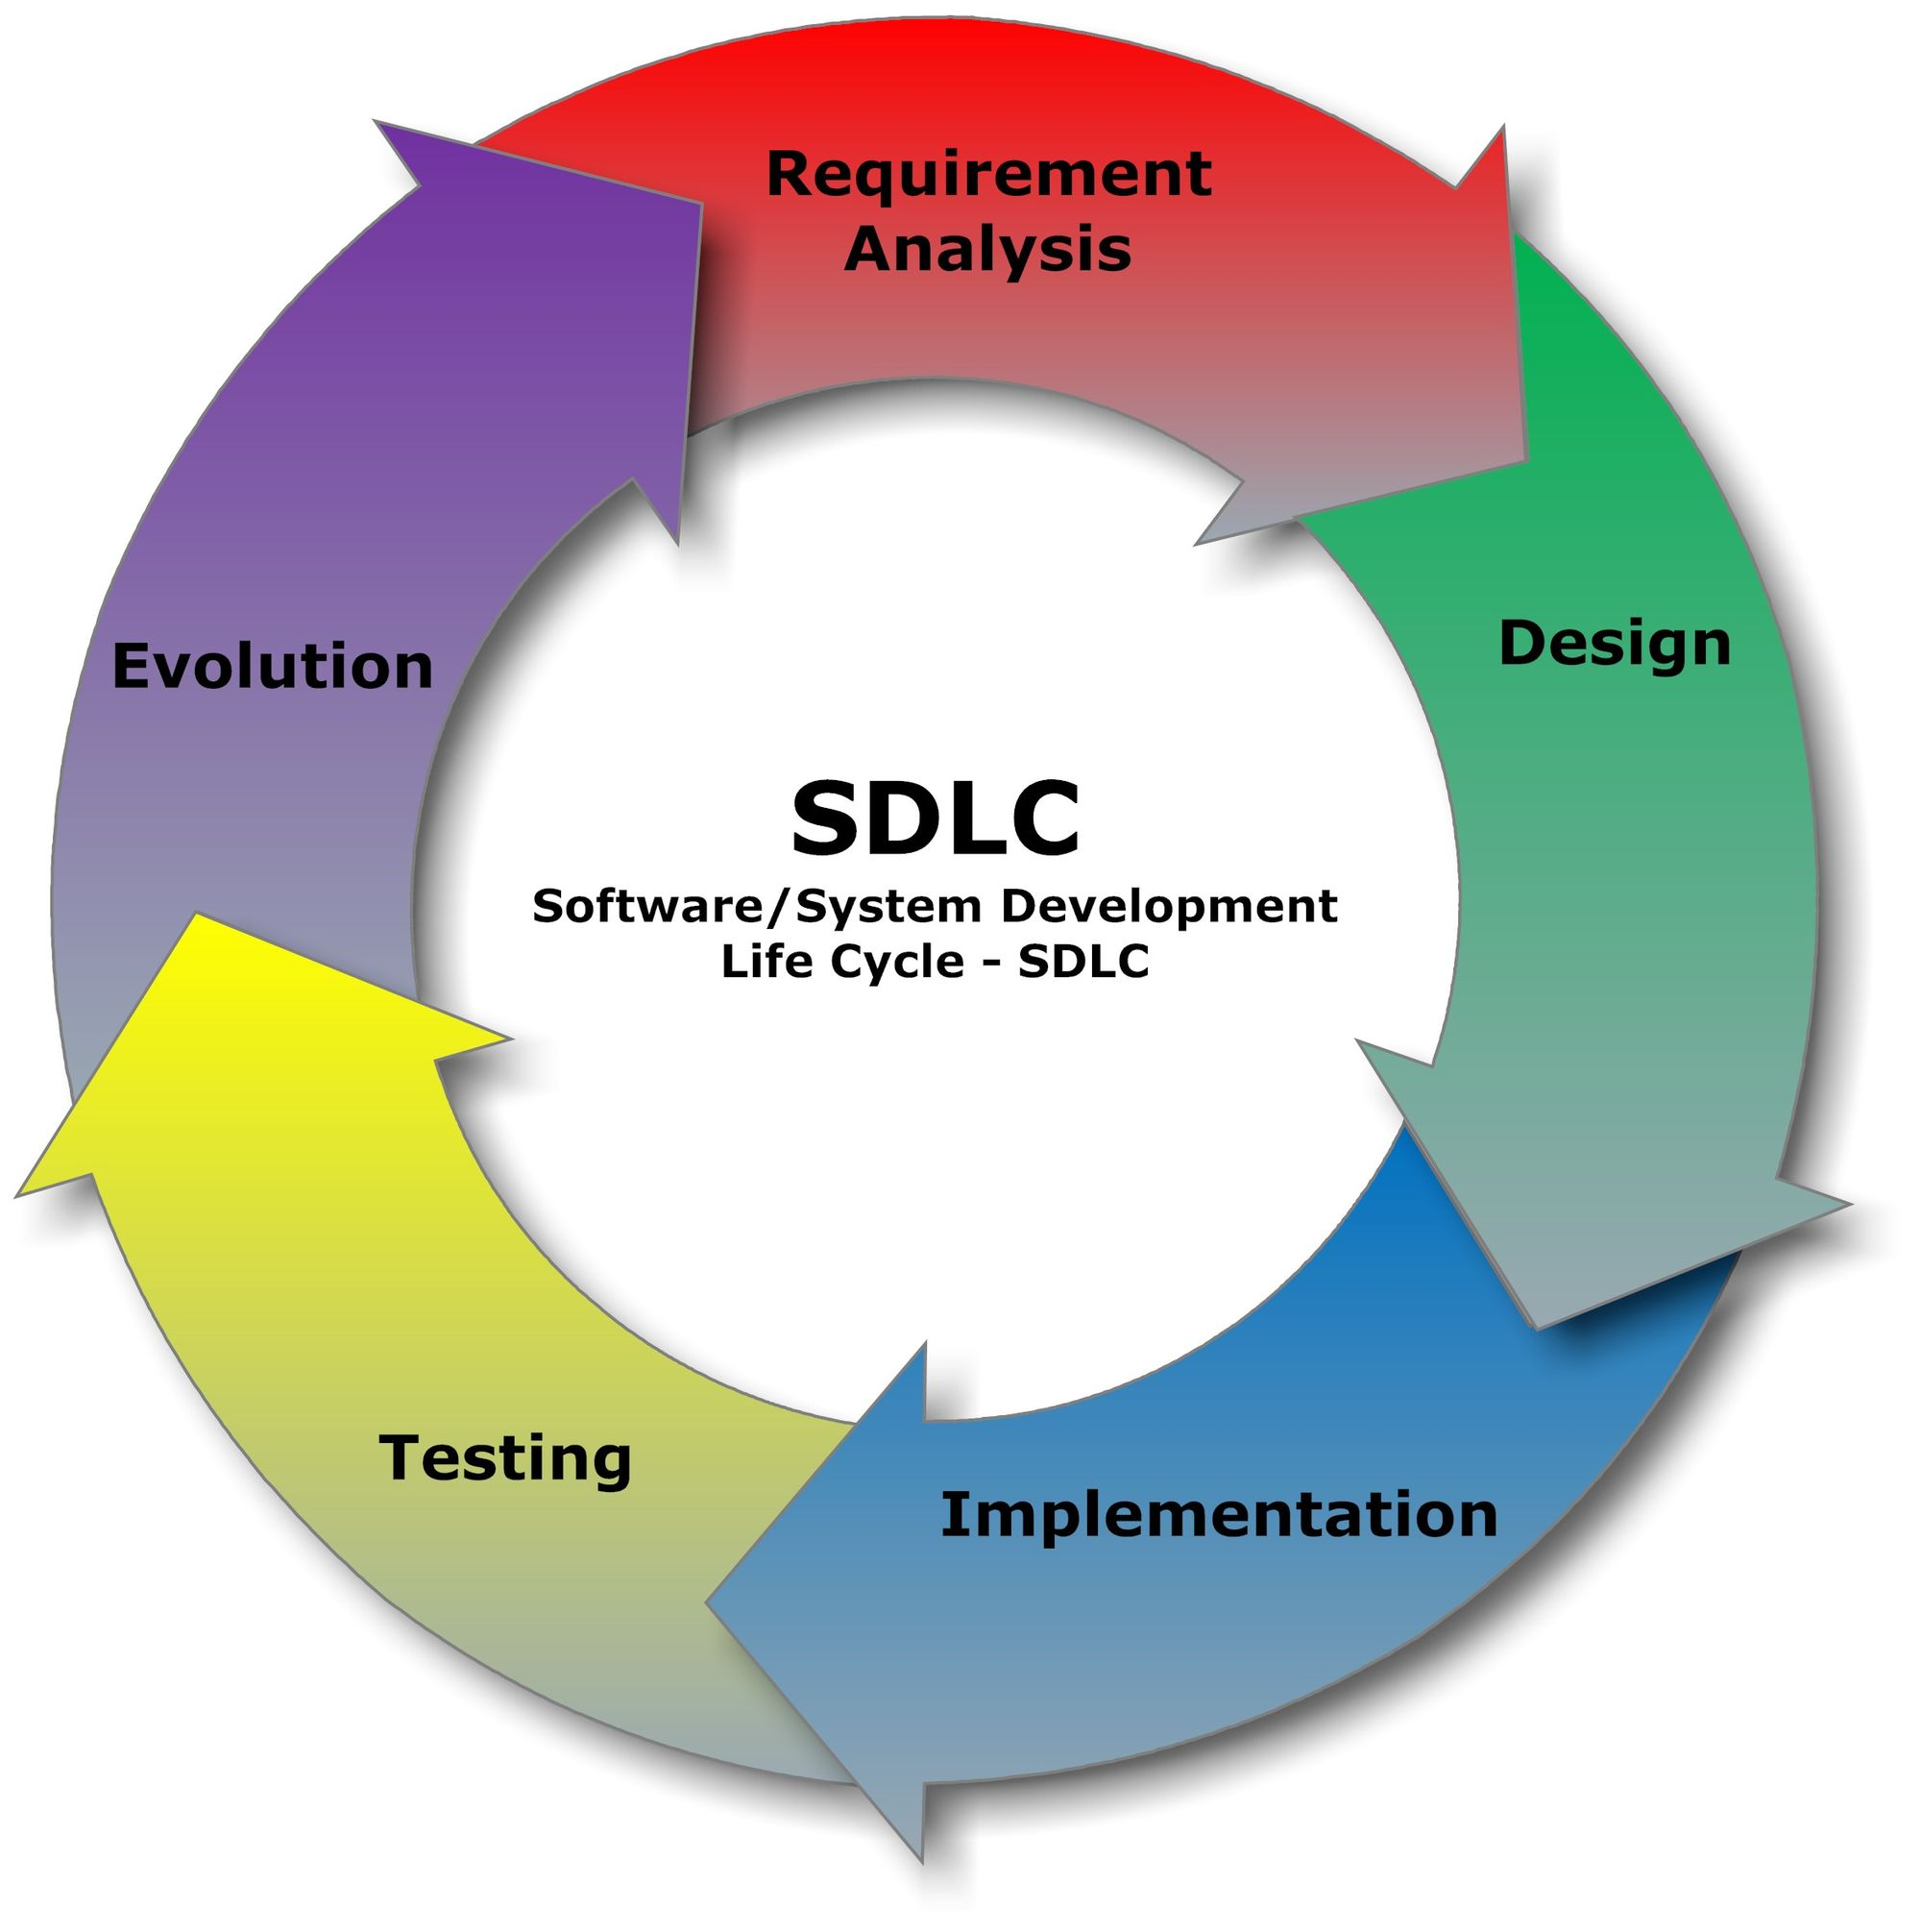

Requirement Analysis

## Requirement Analysis:

**Functional Requirements:**

* Organization has following basic requirements to be performed by the website. So, user can be able to get following functionality from website.

• Information about online flight ticket booking system.

• Information about different types of airline ticket booking.

• Admin can view and approve or cancel booking detail.

• User Can View ticket and cancel his booking.

• User able to update registration details.

• Secure User Login account.

Designing

* **Designing**:
* Once the analysis is done now it’s time for designing. It is the process by which a person creates a specification of a software artifact, intended to accomplish goals, using a set of primitive components and subject to constraints

.

* Software design usually involves problem solving and planning a software solution.

* This includes both low-level component and algorithm design and high-level, architecture design.
* After completing work related to information collecting we started to work on the designing the website.
* We designed a database, a master page for Admin as well as for user also then we started designing each & every web page of the website.

Implementation

* **Implementation:**

* This phase is initiated after the system has been tested and accepted by the user.
* In this phase, the system is installed to support the intended business functions.
* System performance is compared to performance objectives established during the planning phase.
* Implementation includes user notification, user training, installation of hardware, installation of software onto production computers, and integration of the system into daily work processes.
* This phase continues until the system is operating in production in accordance with the defined user requirements.

Coding

* **Coding**:
* The design must be translated in machine readable form. It performs this task. If design is performed in a detailed manner, code generation can be accomplished mechanically.
* When the designing was completed we implemented the logic of the form into the .php and .css files by debugging each.

Testing

# **Testing:**

* Once code has been generated, software testing begins. It is done before the release to the final audience. Software testing is meant to see how the software works under different conditions.

* Testing is done to understand if it will work correctly, partially fail to work properly, or totally fail to work properly.
* Each test may be used to see how one, or many, parts of the software work at a point in its development.
* Prescriptive process models define a distinct set of activities, actions, tasks, milestones, and work products, that are required to engineer high-quality software.
* They do provide a useful roadmap for software engineering work. We discuss here the strategy of the system development in detail as the Register and search Application is developed using this strategy.
* The SDLC method is classically thought of as the set of activities that Analyst, designer and user carry out to develop and implement an information system. This method consists of six steps.

## Modules of the Project:

1. **User module**

* Each of the user, who want to online ticket book, must first register with the Software.
* For the registration part each person enters their details first name, last name,mobile number, e-mali.id,gender, password & confirm password, act the Software

* Once the registration is complete, the user can log-in to the website & make ticket booking of different way in airline .

1. **Admin Module** 
   * + - The module will be protected by user ID and password. Ordinary users of the software will not be permitted to enter into this area of the software.

* + - * The module will be focusing on the maintenance like Master Data Maintenance, Removal of old and outdated data from the software.

Feasibility Study

* **Feasibility Study**
* **Definition:**
* Feasibility study is the initial design stage of any project, which brings together the elements of knowledge that indicate if a project is possible or not.
* Feasibility study is most important and it concerns great to the customer, for which new system is to be developed.
  + - * It includes the study of success and level of satisfaction that the customer and the user will get from the system.
      * Feasibility means possibilities, i.e. this study explores the possibility of implementation of new system as a substitute to old system removing all shortcomings and including all new requirements.
* **The feasibility study is needed to:**

* + - Answer the question whether a new system is to be installed or not?
    - Determine the potential of the existing system.
    - Improve the existing system.
    - Know what should be embedded in the new system
    - Define the problems and objective involved in a project.
    - Avoid costly repairs at a later stage when the system is implemented.
    - Avoid crash implementation of a new system.
    - An initial determine in a proposal that whether an alternative system is feasible or not. To determine of candidate system in all respect I need to consider following feasibility factors:
      1. Operational feasibility
      2. Technical feasibility
      3. Economic feasibility
  1. **Operational Feasibility :**
* Our application has such a user friendly GUI that any person having a sound knowledge of computer can operate the system.
  1. **Technical Feasibility :**
* It is determined by the hardware and supporting software. Hardware requirements: stand-alone computer with enough main memory space & backup storage more than 2 GB to support RDBMS and huge database.
  1. **Economic Feasibility :**
* Project is also economically Feasible. This doesn’t require any costly software or any hardware tools. The technique of cost benefit analysis is often used as a basic for assessing economic feasibility.

**Project Design**

Project Design

Systems design is the process or art of defining the architecture, components, modules, interfaces, and data for a system to satisfy specified requirements. One could see it as the application of systems theory to product development. There is some overlap with the disciplines of systems analysis, systems architecture and systems engineering.

## System design is divided into two types:

* **Logical** **Design:**

The logical design of a system pertains to an abstract representation of the data flows, inputs and outputs of the system. This is often conducted via modelling, which involves a simplistic (and sometimes graphical) representation of an actual system. In the context of systems design, modelling can undertake the following forms, including:

* + - * Data flow Diagrams
      * Use Case Diagrams
      * Entity Relationship Diagrams

## Physical Design:

The physical design relates to the actual input and output processes of the system. This is laid down in terms of how data is inputted into a system, how it is verified / authenticated, how it is processed, and how it is displayed as output.

## System Design includes following points:

* **Requirements analysis** - analyses the needs of the end users.
* **Benchmarking** — is an effort to evaluate how current systems are used.
* **Systems architecture** - creates a blueprint for the design with the necessary specifications for the hardware, software, people and data resources. In many cases, multiple architectures are evaluated before one is selected.
* **Design** — designers will produce one or more 'models' of what they see a system eventually looking like, with ideas from the analysis section either used or discarded. A document will be produced with a description of the system.
* **System testing** - evaluates the system's actual functionality in relation to expected or intended functionality, including all integration aspects.

Database Normalization

* + - **What is Normalization?**

* Normalization is the process of moving data into related tables

* This is usually done by running action queries (Make Table and Append

queries)….unless you’re starting from scratch – then do it right the first time!

**Types of Normalization**

#### **First Normal Form**

* + Each field contains the smallest meaningful value
  + The table does not contain repeating groups of fields or repeating data within the same field
  + Create a separate field/table for each set of related data.
  + Identify each set of related data with a primary key

#### **Second Normal Form**

* + Usually used in tables with a multiple field primary key (composite key)
  + Each non-key field relates to the entire primary key
  + Any field that does not relate to the primary key is placed in a separate table

* **MAIN POINT –**
  + - * Eliminate redundant data in a table
      * Create separate tables for sets of values that apply to multiple records

#### **Third Normal Form**

* + usually used in tables with a single field primary key
  + records do not depend on anything other than a table's primary key
  + each non-key field is a fact about the key
  + Values in a record that are not part of that record's key do not belong in the table. In general, any time the contents of a group of fields may apply to more than a single record in the table, consider placing those fields in a separate table.

Data Dictionary

## Data Base Name: Airline

 **List of Tables:**

1. **admin**
2. **register**
3. **contact**
4. **feedback**
5. **gallery**
6. **oneway_booking**
7. **roundway_booking**
8. **add_destination**
   * A data dictionary is a file or a set of files that contains a database's metadata.
   * The data dictionary contains records about other objects in the database, such as data ownership, data relationships to other objects, and other data.
   * The data dictionary is a crucial component of any relational database.
   * Ironically, because of its importance, it is invisible to most database users. Typically, only database administrators interact with the data dictionary.
   * In a relational database, the metadata in the data dictionary includes the following**:**

* Names of all tables in the database and their owners
* Names of all indexes and the columns to which the tables in those indexes relate
* Constraints defined on tables, including primary keys, foreign- key relationships to other tables, and not-null constraints
* For most relational database management systems (RDBMS), the database management system software needs the data dictionary to access the data within a database.

**1.Admin Table**

**Table Name**: admin

**Description:** This table is used to store Admin Login Information

.

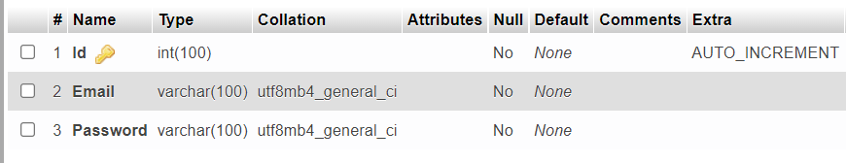

**2.Register Table**

**Table Name**: register

**Description:** This table is used to store Registration Information

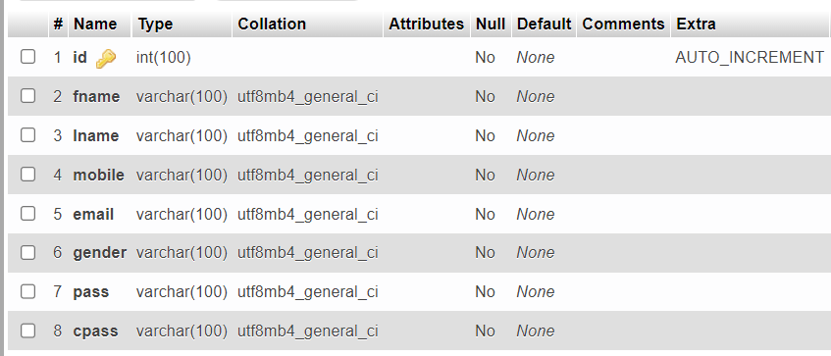

**3.Contact Table**

**Table Name**: contact

**Description:** This table is used to store Contact Information

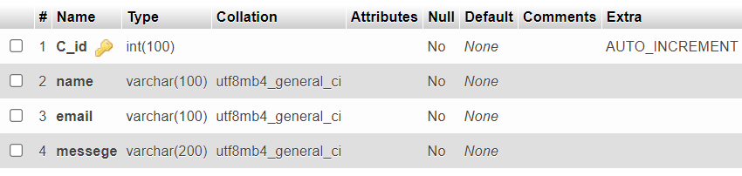

**4.Feedback Table**

**Table Name**: feedback

**Description:** This table is used to store Feedback Information

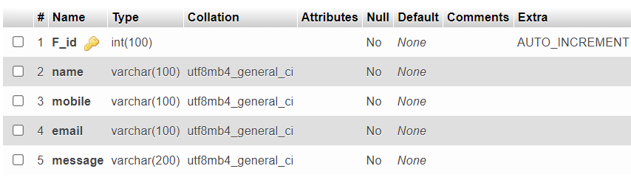

**5.Gallary Table**

**Table Name**: gallary

**Description:** This table is used to store Gallary Information

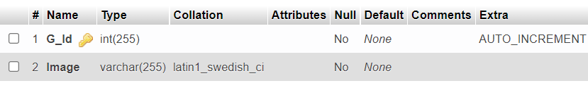

**6.OneWay Booking Table**

**Table Name**: oneway_booking

**Description:** This table is used to store OneWay Booking records

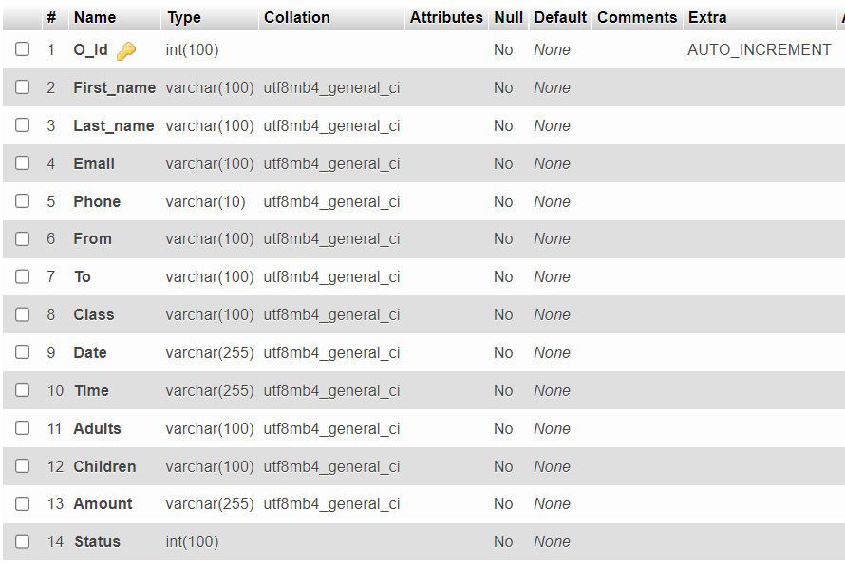

**7.RoundWay Booking Table**

**Table Name**: roundway_booking

**Description:** This table is used to store RoundWay Booking records

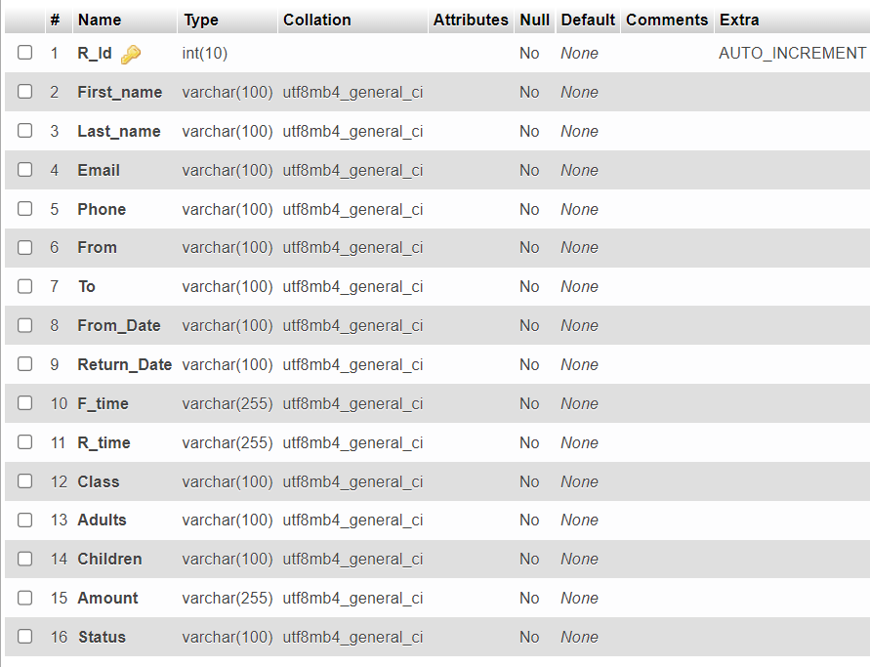

**8.Add Destination Table**

**Table Name**: add_destination

**Description:** This table is used to store Add Destination Information

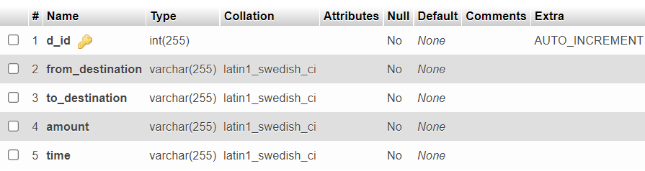

Data Flow Diagram

## Data Flow Diagram (DFD)

* The Data Flow Diagram (DFD) is a graphical representation of the flow of data through an information system.
* It enables you to represent the processes in your information system from the viewpoint of data.
* At a technical level, we did as all other programmers begin with the series of modelling task that lead to complete specification of requirements and comprehensive design representation for the software to be built.
* We used data flow diagrams to represent the information flow and Transforms that are applied as data move from input to output.

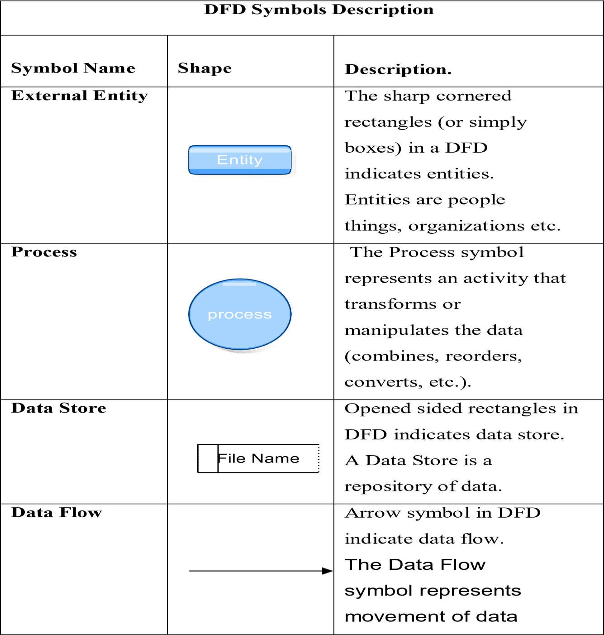

* There Three Type of Data flow diagram:
  + - 1. **Level** **0** **or** **Context** **Diagram**
      2. **Level** **1** **Diagram**
      3. **Level** **2** **Diagram**
    1. **Level 0 or Context Diagram**
* It is common practice to draw the context-level data flow diagram first, which shows the interaction between the system and external agents which act as data sources and data sinks. This helps to create an accurate drawing in the context diagram.
* The system's interactions with the outside world are modeled purely in terms of data flows across the system boundary. The context diagram shows the entire system as a single process, and gives no clues as to its internal organization.
  + 1. **Level 1 Diagram**
* This context-level DFD is next "exploded", to produce a Level 1 DFD that shows some of the detail of the system being modelled.
* The Level 1 DFD shows how the system is divided into subsystems (processes), each of which deals with one or more of the data flows to or from an external agent, and which together provide all of the functionality of the system as a whole.

**3.Level 2 Diagram**

* + - * A level 2 data flow diagram (DFD) offers a more detailed look at the processes that make up an information system than a level 1 DFD does. It can be used to plan or record the specific makeup of a system.
      * To edit this DFD level 2 template, just sign up for a free Lucid chart account. You can then input the particulars of your own system.

# **1. Airline (Level-0)**

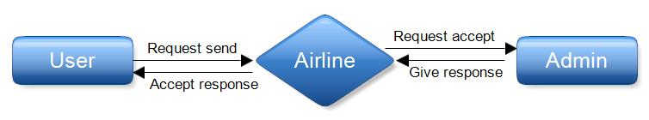

**Admin** **Side** **(Level-1)**

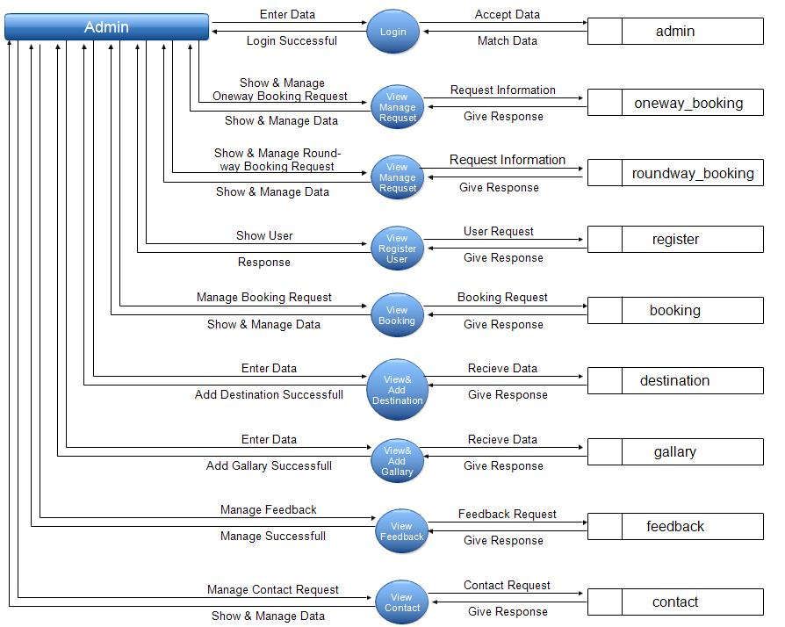

**User** **Side** **(Level-1)**

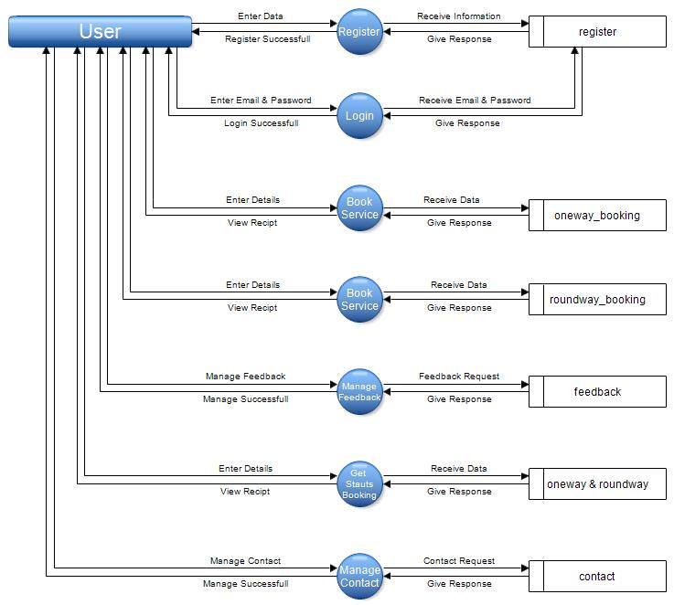

# **ER Diagram**

* An entity-relationship diagram (ERD) is a data modeling technique that graphically illustrates an information system's entities and the relationships between those entities.
* An ERD is a conceptual and representational model of data used to represent the entity framework infrastructure.
* Database troubleshooting: ER diagrams are used to analyze existing databases to find and resolve problems in logic or deployment.
* Drawing the diagram should reveal where it's going wrong. Business information systems: The diagrams are used to design or analyze relational databases used in business processes.
* An entity-relationship model (ERM) is a theoretical and conceptual way of showing data relationships in software development.
* ERM is a database modeling technique that generates an abstract diagram or visual representation of a system's data that can be helpful in designing a relational database.

**The** **steps** **involved** **in** **creating** **an** **ERD** **are:**

* Identify the entities.
* Determine all significant interactions.
* Analyze the nature of the interactions.

## ➔Entity Relationship Diagram Notations

Peter Chen developed ERDs in 1976. Since then Charles Bachman and James Martin have added some slight refinements to the basic ERD principles.

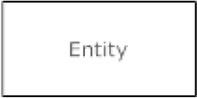**Entity**

An entity is an object or concept about which you want to

store information

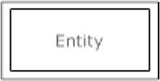**Weak Entity**

Attributes are the properties or characteristics of an entity.

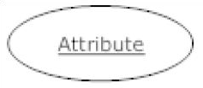**Key** **attribute**

A key attribute is the unique, distinguishing characteristic of the entity. For example, an employee's social security

number might be the employee's key attribute.

**Multivalued** **attribute**

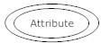 A multivalued attribute can have more than one value. For example, an employee entity can have

multiple skill values.

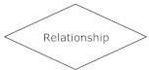**Relationships**

Relationships illustrate how two entities share information in the database structure.

# **ER Diagram**

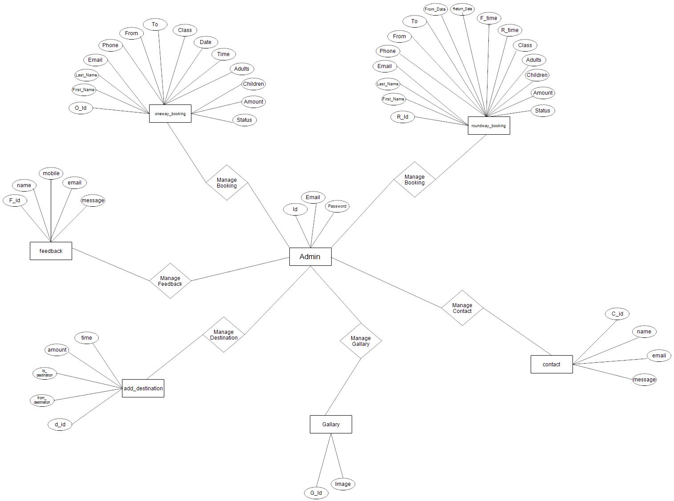

## Use-Case Diagram

* A use case diagram is a graphic depiction of the interactions among the elements of a system. A use case is a methodology used in system analysis to identify, clarify, and organize system requirements. The actors, usually individuals involved with the system defined according to their roles.
* UML Use Case Diagrams. Use case diagrams are usually referred to as behavior diagrams used to describe a set of actions (use cases) that some system or systems (subject) should or can perform in collaboration with one or more external users of the system (actors).
* The main purpose of a use case diagram is to show who interacts with your system, and the main goals they achieve with it. Create Actors to represent classes of people, organizations, other systems, software or devices that interact with your system or subsystem.
* Use Cases. A use case is a written description of how users will perform tasks on your website. It outlines, from a user's point of view, a system's behavior as it responds to a request. Each use case is represented as a sequence of simple steps, beginning with a user's goal and ending when that goal is fulfilled.

|  |  |  |
| --- | --- | --- |
| **Use Case Symbols Description** | | |
| **Symbol Name** | **Shape** | **Description** |
| **Actor** |  | Similar to the concept of user, but a user can play different roles. |
| **Use Case** |  | Each Actor must  be linked to a use case, while  some  use cases may not be linked  to  actors. |
| **Communication Link** |  | The participation of an actor in a use case is  shown by  connecting a actor to a use case by a solid link. |
| **Boundary Of System** |  | The system boundary is  potentially the entire system as defined in the requirements  document. |

# **Admin Side**

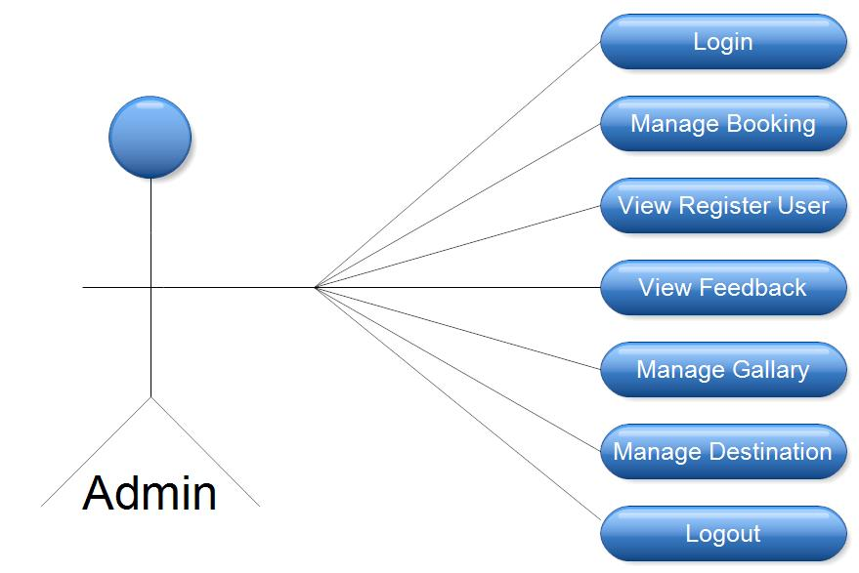

# **User Side**

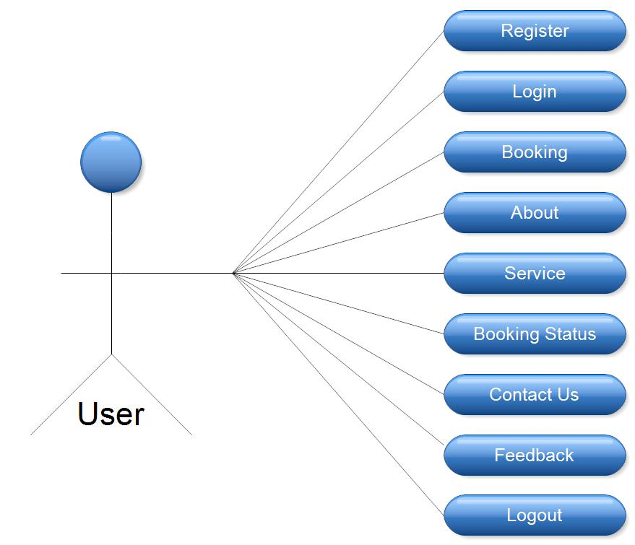

* **Admin Panel :**

**Admin Login**

**Oneway Booking**

**Roundway Booking**

**View All Records**

**View Register User**

**View Booking Details**

**View Destination**

**View Feedback**

**View Contact**

**View Gallary**

**Add Details**

**Add Destination**

**Add Gallary**

* **User Panel :**

**Home Page**

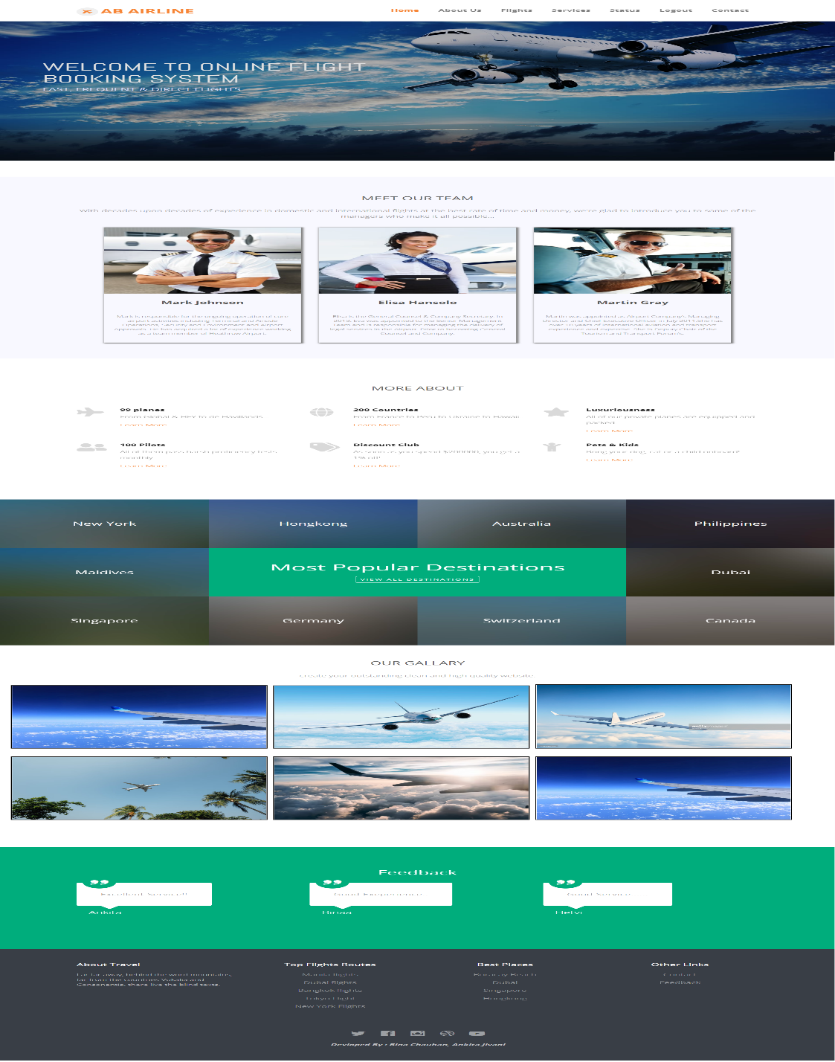

**Registration**

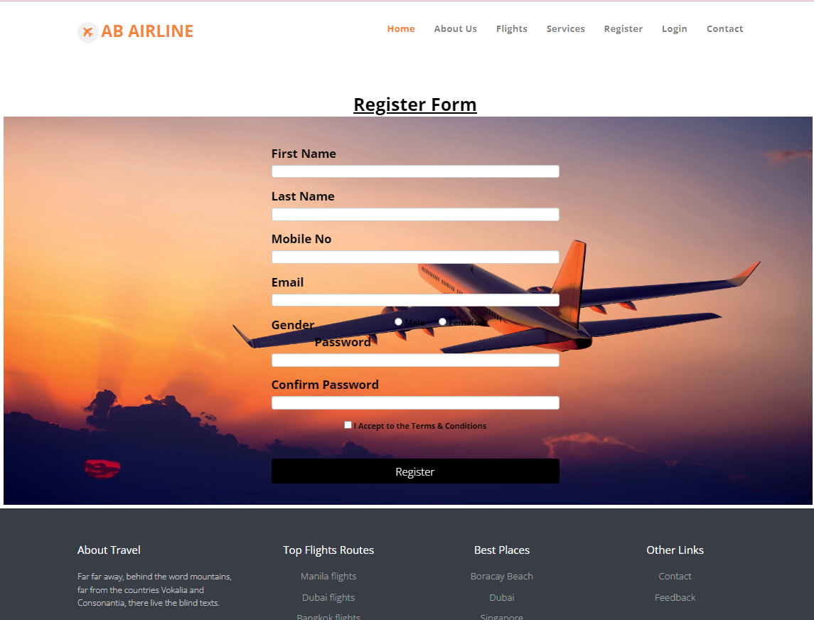

**About Us**

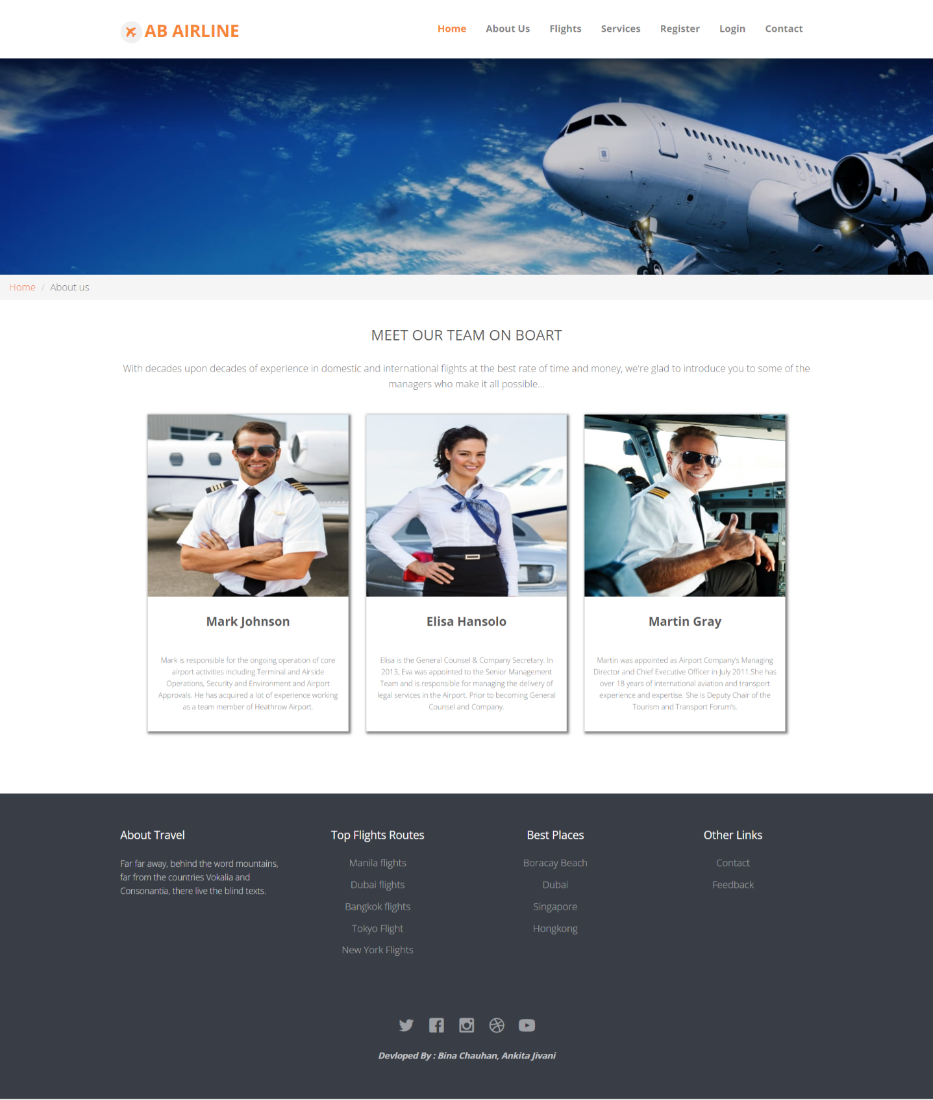

**Services**

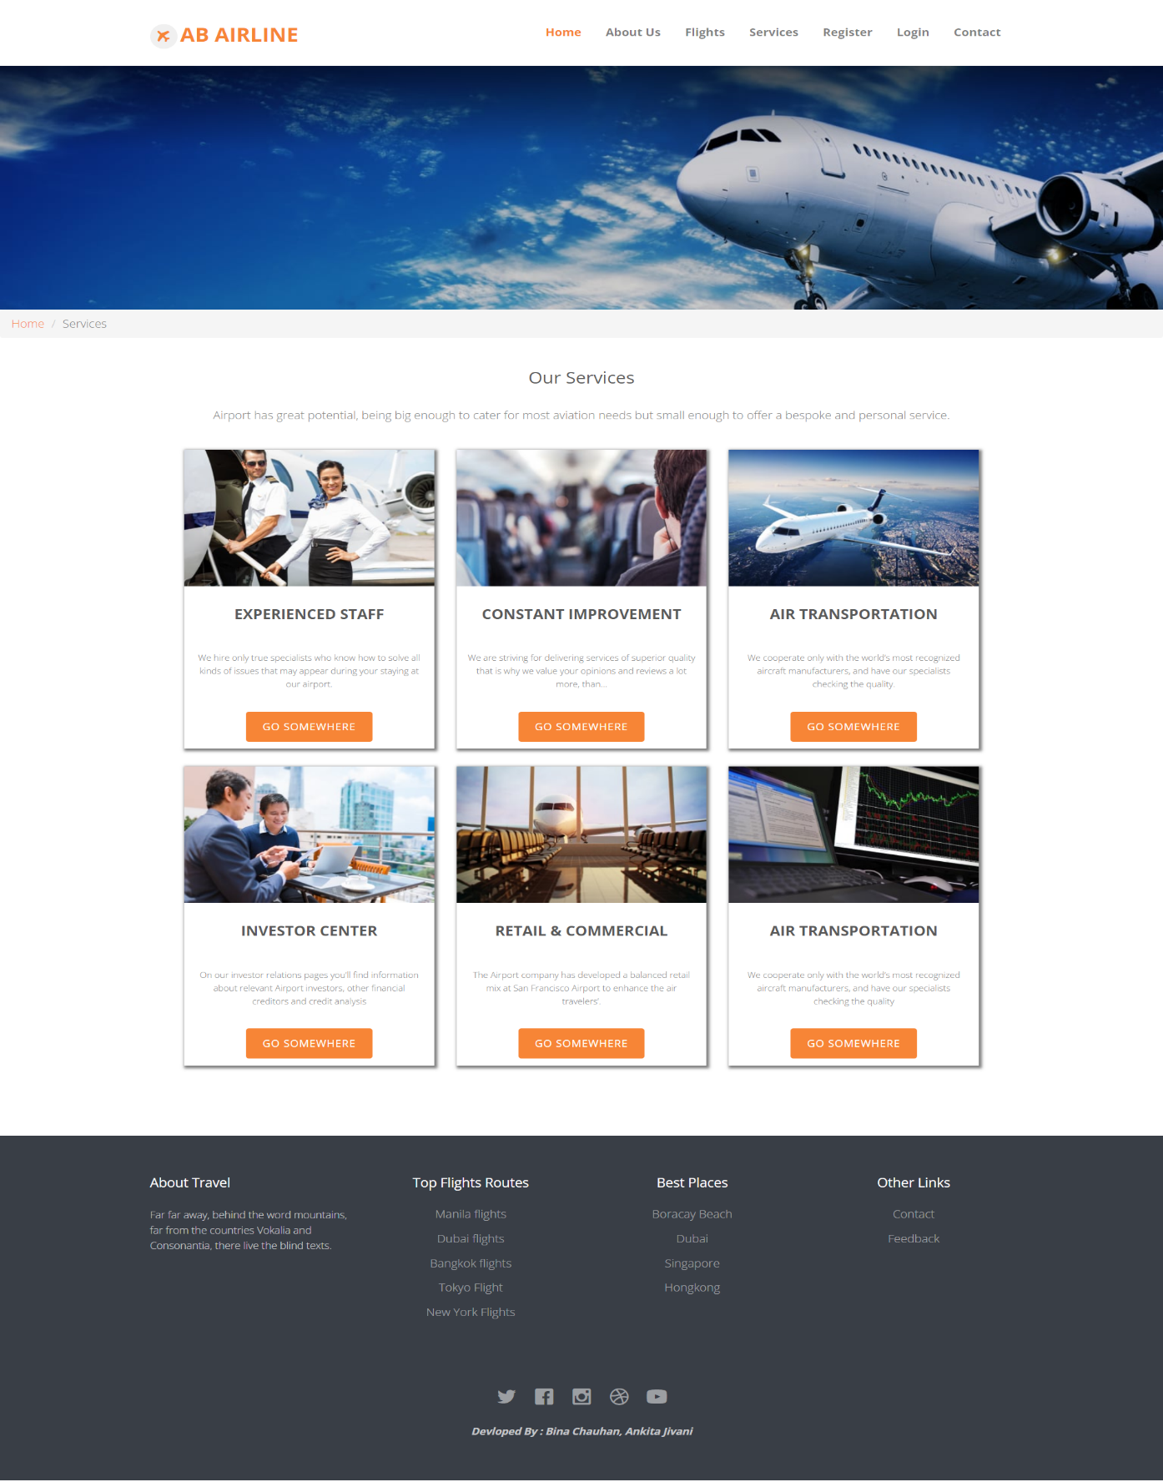

**Booking Form**

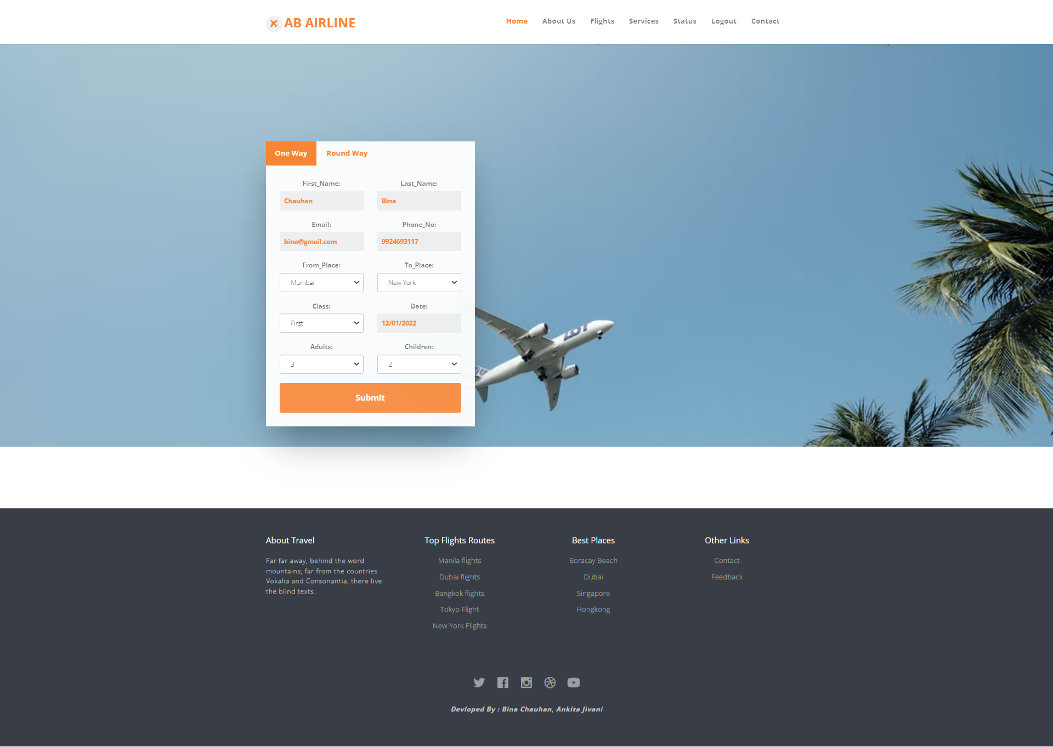

**Status Page**

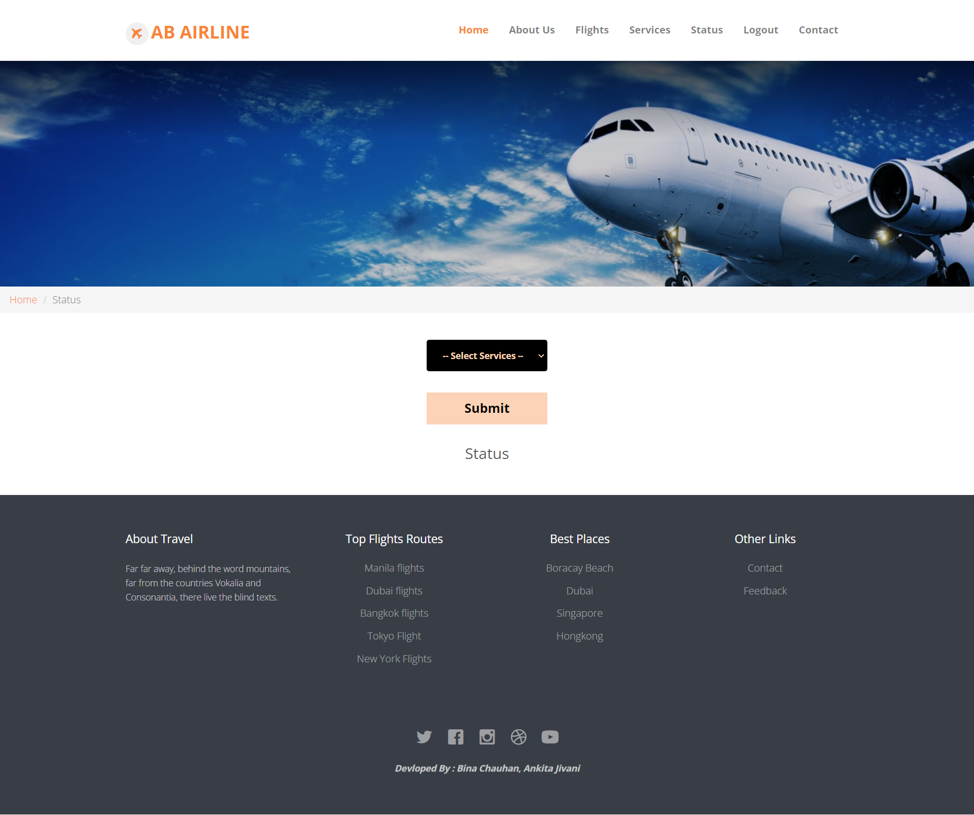

**Feedback**

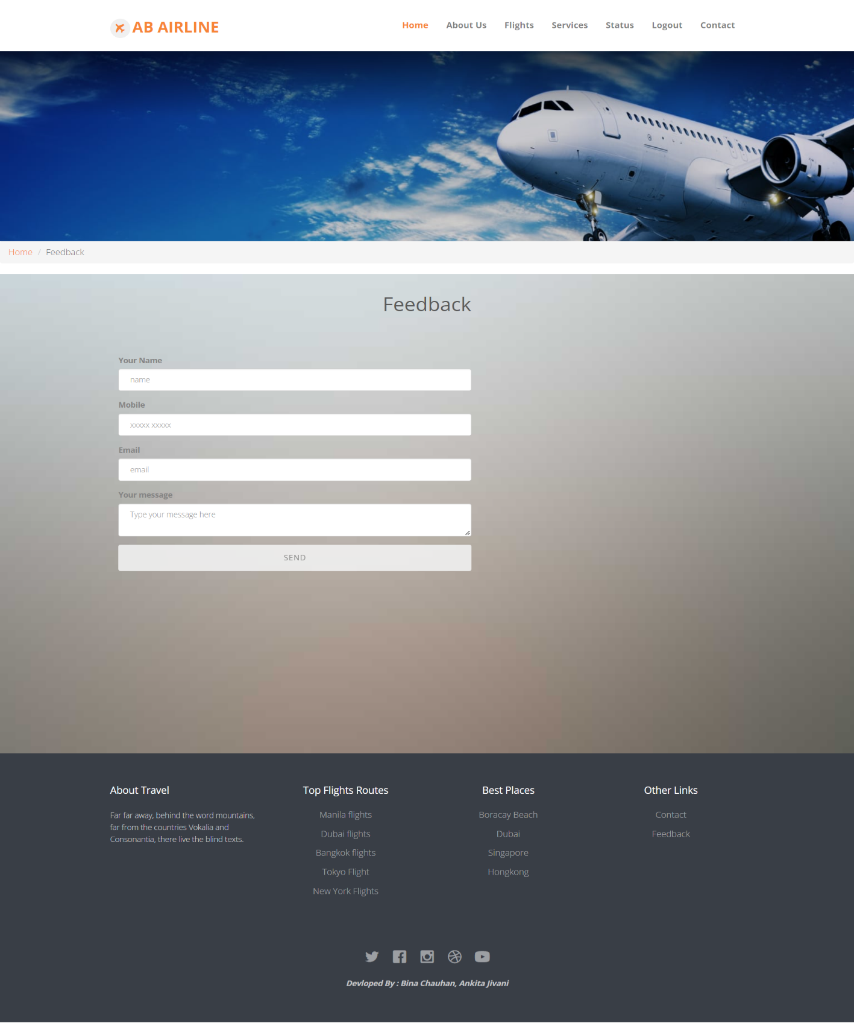

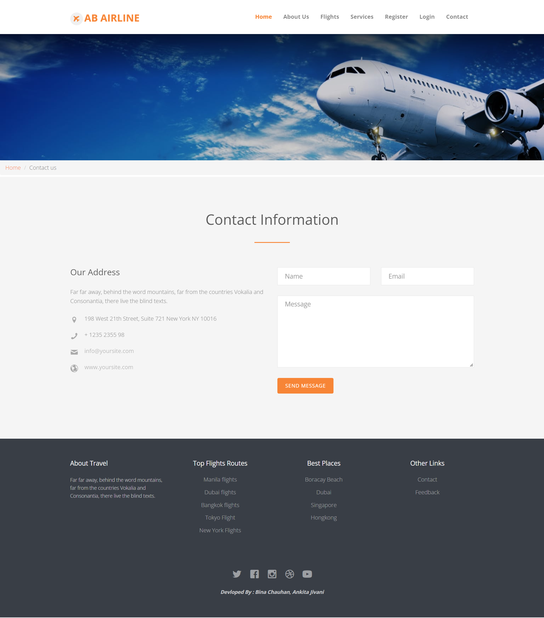**Contact Us**

## Testing Mechanism

## Testing Mechanism

* + Testing is process to finding the errors in the program.
  + Testing is a process to show the corrections of the program.
  + Testing is needed to show completeness, to improve the quality of the software and to provide the maintenance aid.
  + Some testing standards are therefore necessary reduce the testing costs and operation time.
  + Testing software extends throughout the coding phase and it represents the ultimate review of configurations, design and coding. Based on the way the software reacts to these testing.
  + We can decide whether the configuration that has been built is study or not.
* All components of an application are tested, as the failure to do so many results in a series of bugs after the software is put to use.

1. **Unit Testing**

* This site is designed for Information Technology Professionals who need to improve quality and require guidance and direction to help teams consistently produce error free results.
* It provides information management guidelines for software unit testing.

### **What is module testing?**

* The objective of module testing is to certify that each individual module isbuilt to design specifications in the developer’s personal schema and is ready for system testing in a system test environment.
* Information management projects generally have the following development work:
  + Data integration software
  + Data conversion software
  + Data cleansing routines
  + Data base development DDL; and
  + Business intelligence and reportinganalytical solutions.
* Module testing validates that each module's logic meets design specification. It is generally conducted by the developer who develops the code.

1. **Black-box** **Testing**
   * This testing methodology looks at what are the available inputs for an application and what the expected outputs are that should result from each input.
   * Black box testing also called behavioural testing, focuses on the functional requirement of software.
   * This testing approach enables the software engineer to drive the input conditions that will fully exercise all requirements for a program.

**C. White-box Testing**

* White box testing is also called Glass box testing is a test case design control structure of the procedural design to derive test cases using white box testing method.
* This testing methodology looks under the covers and into the subsystem of an application. White-box testing enables you to see what is happening inside the application.
* The software engineer can drive the test cases that guarantee that all independent paths within the module have been exercised at least once.

d. **Grey-box** **Testing**

* Grey-box testing is a technique to test the application with having a limited knowledge of the internal workings of an application.
* In software testing, the phrase *the more you know, the better* carries a lot of weight while testing an application.
* Mastering the domain of a system always gives the tester an edge over someone with limited domain knowledge.
* Unlike black-box testing, where the tester only tests the application's user interface; in grey-box testing, the tester has access to design documents and the database.
* Having this knowledge, a tester can prepare better test data and test scenarios while making a test plan.

**Implementation Mechanism**

Spiral Model

The Spiral Model is a combination of sequential and prototype model. This model is best used for large projects which involves continuous enhancements.

* There are specific activities which are done in one iteration (spiral) where the output is a small prototype of the large software.
* The same activities are then repeated for all the spirals till the entire software is build.

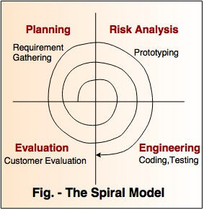

* How we use Spiral model?

There are four phase of spiral model implementation:

## Planning

* + We decide do the project on “Transport management system” with some module.
  + We analys the data and the actual situations of systems.
  + We make list of requirement as needed.

## Risk Analysis

* + We analys the risk and faults of the system.
  + We see the errors in the system.
  + We analys the data loss of the user or admin with login and other faults.

## Codding & Testing

* + We create a design and create the pages as per the design.
  + Codding must have error free so the result become pure.

## Feedback

* + The contact page is created for the user that give us the feedback from the users.
  + It will help to make improvement.
  + It is most Needed thing for improvements.

Future Score

## Over future Score Are follows :

* + - The system at any point of time can provide the details of the ComputerMaintenance System and theUsers.
    - The system at any point of time can provide details of Maintenance and the registerd issues.
    - The system at any point of time can provide details of Maintenance fault and in sequence.
    - The system at any point of time can provide details of Maintenance existing reports and theirstatus.

**BIBLIOGRAPHY**

For the successful working of our project we are referred many sources for the code snippets, logic and tips and tricks from the various web sites. Most I searched for the required possessions on the google.com search engine.

* Sites: -

1. **[www.otrams.com](http://www.otrams.com)**

1. **[www.templatemonster.com](http://www.templatemonster.com)**

1. **[www.farecompare.com](http://www.farecompare.com)**

* Organization : -

Dr. Subhash Of Computer Science